**Lesson 5**

* Comments on previous lesson.
* Today’s lesson activities.
* Do the activities on this document and upload it on POLIFORMAT – TAREAS.
* Deadline: During today’s class time

**Practice 5 - Transport**

**Listening**

You’re going to hear a talk about cycling. You will hear the talk twice. The first time, just listen. Try to understand generally what the speaker is talking about.

The task will play once

**Can you tell me in one or two sentences what the speaker was talking about?**

She talk about the increase of cycling and if is a good idea take it every day.

Now listen to the talk again. This time make some notes as you listen. Then I’ll ask you to tell me what the speaker says the advantages and disadvantages of cycling are. Are you ready?

The task will play once.

**Now write down what the speaker says the advantages and disadvantages of cycling are.**

✘ Is a dangerous transport way, there are a loto f accidents and there’s not enough traffic lights.

Also it is not confortable in areas where there are extreme temperatures

✓is healthy, companies makes easier take a bike

Reduce the polution

Is cheaper than than a car

as

Record a **1.5-MINUTE FLIPGRID** in which you tell me what the advantages and disadvantages of cycling are according to the recording and give your opinion about it. I’ll stop you after one minute and a half.

* **Use contrast connectors**
* **Use expressions to report what has been said in the recording (‘as they say…’, ‘according to…’)**
* **Use opinion expressions**

**Speaking**

**Discuss the ideas in the interaction and the questions below in your assigned chat rooms. Make a decision. Record the interaction in the chat rooms. Interaction (3 minutes in pairs / 4 minutes groups of 3):**

* **Use agreeing and disagreeing expressions**
* **Use expressions to summarise the main conclusions**
* **Remember to show interest, invite people to speak, react to what others say**

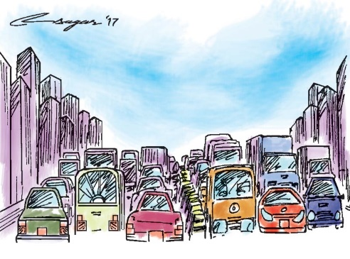**A. What are the advantages and disadvantages of these measures to improve the traffic flow in a city? Which is the best one?**

* How do you prefer to get round the city? Why?
* Have you ever experienced any traffic problems? Which ones? / How would you feel if you experienced them?

**Listening**

**Listen to a recording about how Sweden improved their road safety. Answer the questions:**

1. What cause the number of deaths to double?

-

1. What was the big change the government made?

-drive on the left

1. What infrastructure changes took place?

-

-

-

-

-

1. What did the Swedish Royal Safety Agency achieve?

-

-

1. Why was it possible to reduce the number of fatalities?

-

-

1. What is the ultimate goal they have?

-

**Speaking**

**Discuss the ideas in the interaction and the questions below in your assigned chat rooms. Make a decision. Record the interaction in the chat rooms. Interaction (3 minutes in pairs / 4 minutes groups of 3):**

* **Use agreeing and disagreeing expressions**
* **Use expressions to summarise the main conclusions**
* **Remember to show interest, invite people to speak, react to what others say**

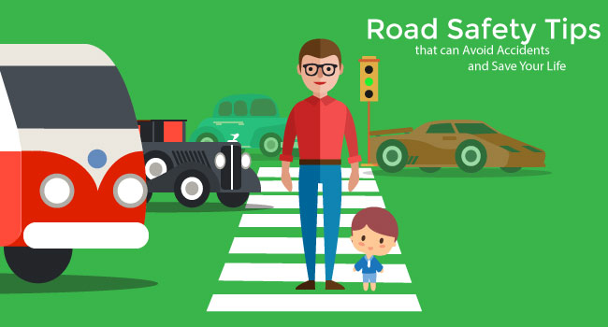**B. How could you increase road safety in your town? Which is the best one?**

* Do you drive? Do you enjoy it? Why / Why not? If you don’t drive, would you like to? Why / Why not?
* How do you feel about the quality of driving in your country? What about other countries you have visited or you have heard of?